|  |  |
| --- | --- |
| **EXP NO:** **10**  **DATE :5/5/25** | **Custom Text Styler with Toast Notification in Android** |

**AIM:**

Develop an application to change the font and color of the text and display toast message when the user presses the button.

**CODE:**

**MainActivity.kt**

package com.Session.servlet;

import android.graphics.Color import android.os.Bundle import android.widget.Button import android.widget.TextView import android.widget.Toast import androidx.activity.enableEdgeToEdge import androidx.appcompat.app.AppCompatActivity import androidx.core.view.ViewCompat import androidx.core.view.WindowInsetsCompat

class MainActivity : AppCompatActivity() { override fun onCreate(savedInstanceState: Bundle?) { super.onCreate(savedInstanceState) enableEdgeToEdge()

setContentView(R.layout.activity_main) var txt:TextView=findViewById(R.id.textView) var btn:Button=findViewById(R.id.button)

var count=0 btn.setOnClickListener { count++

txt.text=count.toString() txt.setTextColor(Color.RED)

txt.setBackgroundColor(Color.BLACK)

Toast.makeText(this,"Color Change and font",Toast.LENGTH_LONG).show() txt.textSize=18f

}

}

}

**activity_main.xml**

<?xml version="1.0" encoding="utf-8"?>

<androidx.constraintlayout.widget.ConstraintLayout xmlns:android="[http://schemas.android.com/apk/res/android"](http://schemas.android.com/apk/res/android) xmlns:app="[http://schemas.android.com/apk/res-auto"](http://schemas.android.com/apk/res-auto) xmlns:tools="[http://schemas.android.com/tools"](http://schemas.android.com/tools) android:id="@+id/main" android:layout_width="match_parent" android:layout_height="match_parent"

tools:context=".MainActivity">

<TextView

android:id="@+id/textView" android:layout_width="wrap_content" android:layout_height="wrap_content" android:text="Hello World!"

app:layout_constraintBottom_toBottomOf="parent" app:layout_constraintEnd_toEndOf="parent" app:layout_constraintHorizontal_bias="0.461" app:layout_constraintStart_toStartOf="parent" app:layout_constraintTop_toTopOf="parent" app:layout_constraintVertical_bias="0.186" />

<Button

android:id="@+id/button" android:layout_width="wrap_content" android:layout_height="wrap_content" android:layout_marginTop="172dp"

android:text="Count"

app:layout_constraintEnd_toEndOf="@+id/textView"

app:layout_constraintHorizontal_bias="0.0" app:layout_constraintStart_toStartOf="@+id/textView" app:layout_constraintTop_toBottomOf="@+id/textView" />

</androidx.constraintlayout.widget.ConstraintLayout>

**OUTPUT:**

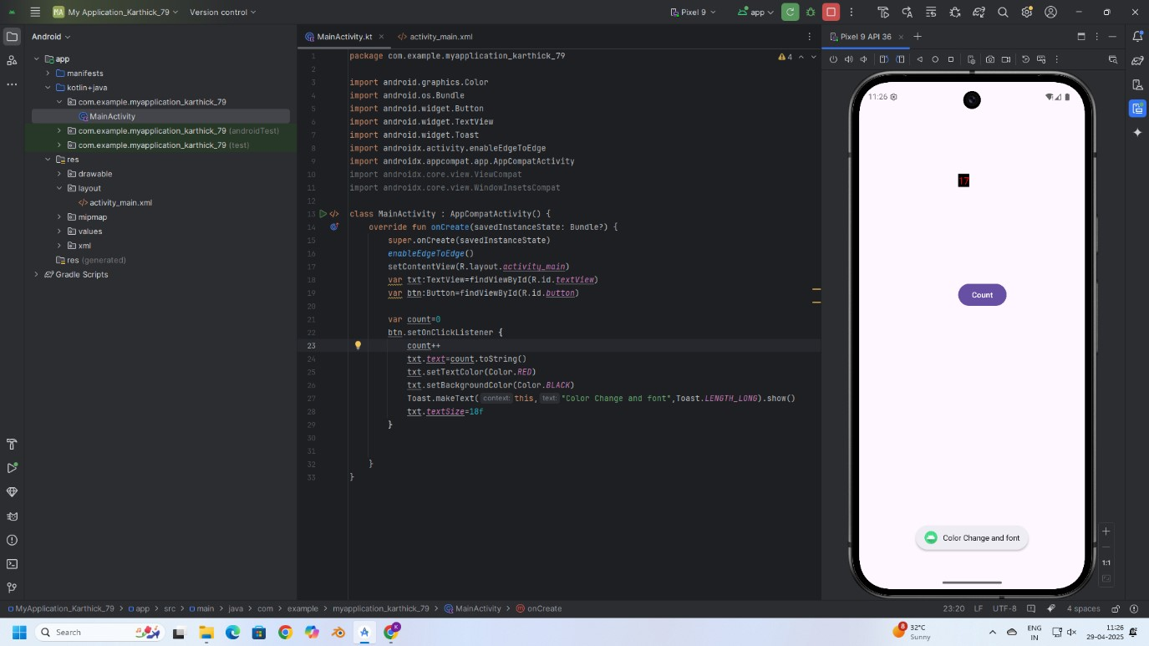

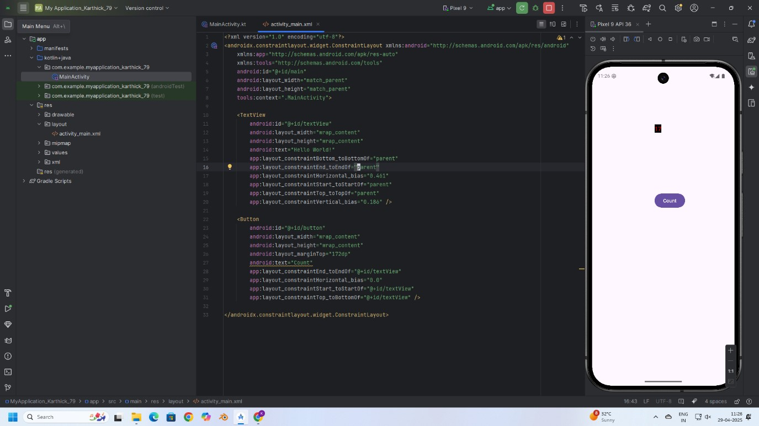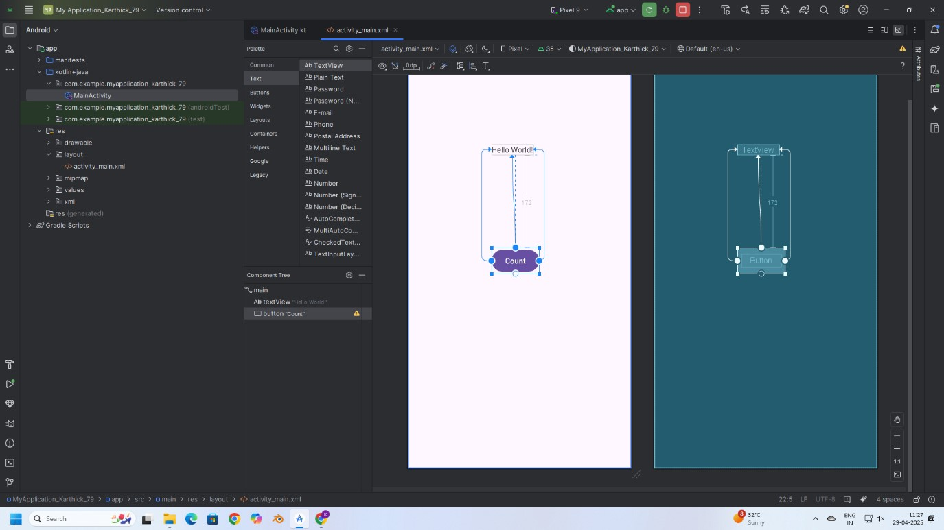

**RESULT:**

Thus, text customization and user interaction were successfully implemented by changing font and color, and displaying a Toast message on button click in the application.